**Software Reverse Engineering** is a process of recovering the design, requirement specifications and functions of a product from an analysis of its code. It builds a program database and generates information from this.

The purpose of reverse engineering is to facilitate the maintenance work by improving the understandability of a system and to produce the necessary documents for a legacy system.

**Reverse Engineering Goals:** 

* Cope with Complexity.
* Recover lost information.
* Detect side effects.
* Synthesise higher abstraction.
* Facilitate Reuse.

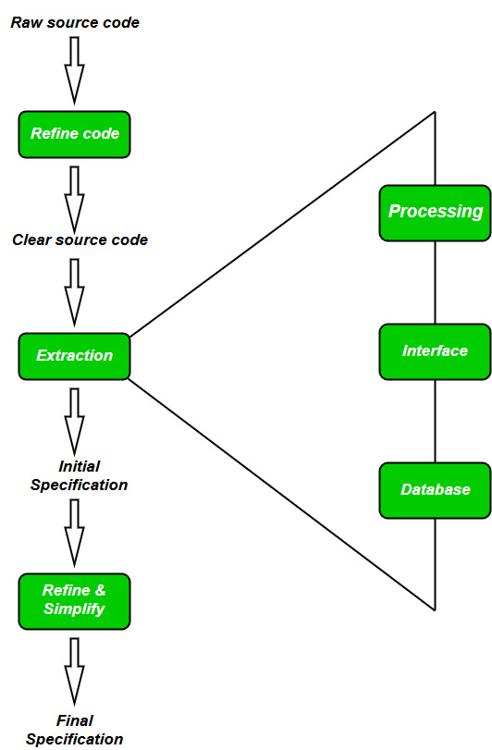

**Steps of Software Reverse Engineering:**

1. **Collection Information:**   
   This step focuses on collecting all possible information (i.e., source design documents etc.) about the software.

1. **Examining the information:**   
   The information collected in step-1 as studied so as to get familiar with the system.

1. **Extracting the structure:**   
   This step concerns with identification of program structure in the form of structure chart where each node corresponds to some routine.

1. **Recording the functionality:**   
   During this step processing details of each module of the structure, charts are recorded using structured language like decision table, etc.

1. **Recording data flow:**   
   From the information extracted in step-3 and step-4, set of data flow diagrams are derived to show the flow of data among the processes.

1. **Recording control flow:**   
   High level control structure of the software is recorded.

1. **Review extracted design:**   
   Design document extracted is reviewed several times to ensure consistency and correctness. It also ensures that the design represents the program.

1. **Generate documentation:**   
   Finally, in this step, the complete documentation including SRS, design document, history, overview, etc. are recorded for future use.

**Reverse Engineering Tools:**

Reverse engineering if done manually would consume lot of time and human labour and hence must be supported by automated tools. Some of tools are given below:

* **CIAO and CIA:** A graphical navigator for software and web repositories along with a collection of Reverse Engineering tools.
* **Rigi:**A visual software understanding tool.
* **Bunch:**A software clustering/modularization tool.
* **GEN++:**An application generator to support development of analysis tools for the C++ language.
* **PBS:**Software Bookshelf tools for extracting and visualizing the architecture of programs.